|  |  |  |
| --- | --- | --- |
|  |  |  |
| **MINISTRY OF HEALTH OF THE REPUBLIC OF UZBEKISTAN** | **MINISTRY OF HIGHER EDUCATION, SCIENCE, AND INNOVATIONS OF THE REPUBLIC OF UZBEKISTAN** | **TASHKENT MEDICAL ACADEMY** |

***INFORMATION LETTER***

*International Scientific and Practical Conference* ***"Endoscopic Surgery in Gynecology and Reproductology: International Experience and Development Perspectives"*** *May 23, 2024, Tashkent, Uzbekistan*

***Начало формы***

***Dear colleagues, dear friends!***

The Tashkent Medical Academy invites you to participate in the International Scientific and Practical Conference "Endoscopic Surgery in Gynecology and Reproductology: International Experience and Development Perspectives," which will take place on May 23, 2024, in Tashkent.

***Conference Organizers:***

Ministry of Health of the Republic of Uzbekistan

Ministry of higher Education, Science, and Innovations of the Republic of Uzbekistan

Tashkent Medical Academy

Department of Obstetrics and Gynecology Tashkent Medical Academy

***Venue:*** *Tashkent, Almazar district, Shifokor St., bldg. 3, Ceremonial Hall of the TMA Academic Lyceum.*

*The congress will be held in offline and online formats*

***For online participation via Zoom:*** [***https://us02web.zoom.us/j/82068102085?pwd=N1lydnB3YUdmSytIdlBNbWVERVFoQT09***](https://us02web.zoom.us/j/82068102085?pwd=N1lydnB3YUdmSytIdlBNbWVERVFoQT09)

***Conference ID:*** *820 6810 2085*

***Access Code:*** *026215*

***Telegram Channel of the Conference:*** [***https://t.me/+VWp753aGVSwxMWYy***](https://t.me/+VWp753aGVSwxMWYy)

***More details on the website:*** [***http://obgyn.proftraining.tma.uz/en/article/3442***](http://obgyn.proftraining.tma.uz/en/article/3442)

***Email for correspondence:*** [***tma.akush.gyn@gmail.com***](mailto:tma.akush.gyn@gmail.com)

***Scientific Directions of the Conference Program:***

* Endoscopic Surgery in Gynecology and Reproductology Today: Achievements, Problems, and Solutions.
* ***Начало формы***
* Innovations in Endoscopic Surgery for the Diagnosis and Surgical Treatment of Reproductive System Diseases.
* Current Trends in Endoscopic Surgery in Gynecology and Reproductology.

The conference will feature participation by leading foreign and domestic specialists in the field of endoscopic surgery in gynecology and reproductology.

**Invited participants include** obstetrician-gynecologists and reproductive specialists.

**The official languages of the conference are** Uzbek, Russian, and English.

**Participation formats in the conference:**

* Oral presentation + thesis publication
* Thesis publication only

**ATTENTION!**

Registration on the official Telegram channel of the conference is mandatory for participation in any format:[**https://t.me/+VWp753aGVSwxMWYy**](https://t.me/+VWp753aGVSwxMWYy)

The materials of the scientific-practical conference will be published in a special issue of the **"Journal of Education & Scientific Medicine,"** which is included in the list of SAC journals.

Theses, prepared in accordance with the requirements, should be submitted to the scientific committee through the conference's Telegram channel:[**https://t.me/+VWp753aGVSwxMWYy**](https://t.me/+VWp753aGVSwxMWYy)

**Theses are accepted until May 15, 2024.**

**THESIS SUBMISSION GUIDELINES**

* Theses are accepted in Uzbek, Russian, and English languages.
* Theses should reflect the relevance, objective, materials and methods of research, results obtained, and conclusion — without section divisions, tables, or figures.
* Each thesis must be accompanied by a brief summary in both Uzbek and Russian languages.
* The text of the thesis must be typed on a computer using Microsoft Word.
* Margins: top and bottom 2 cm, left 3 cm, right 1.5 cm.
* The primary font should be Times New Roman, the font size for the main text should be 12 points, line spacing should be single, text alignment should be justified, and paragraph indentation (first line indent) should be 1.5 cm.
* The thesis file must be saved in .doc format with the surname of the first author in the file name (for example: Mirzaeva.doc).
* The length of the thesis should be 1 page.

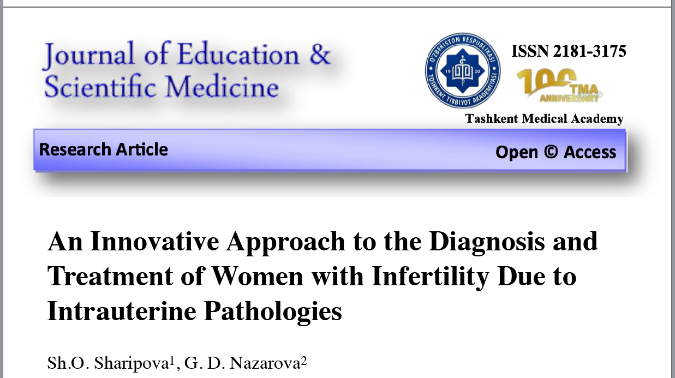

To participate in the conference with a presentation, you must fill out an application for the presentation via the Telegram channel: [**https://t.me/+VWp753aGVSwxMWYy**](https://t.me/+VWp753aGVSwxMWYy)

Only one application for a presentation is accepted from each speaker. If multiple applications for presentations are received from a single speaker, the scientific committee reserves the right to unilaterally choose which presentation to accept from the applicant.

When filling out the application for an oral presentation, you must provide a brief summary (abstract) of your presentation. In the event that multiple speakers submit presentations on the same topic with similar content, the scientific committee reserves the right to exclude repetitive presentations from the program.

**The time allotted for an oral presentation is** 15 minutes.

**Applications for presentations are accepted until** May 10, 2024**.**

**Application for Presentation**

|  |  |
| --- | --- |
| Full name of the presenter (complete, no abbreviations) |  |
| Specialty |  |
| Position |  |
| Academic Degree |  |
| Academic Title |  |
| Place of Work, Institution (full name, no abbreviations) |  |
| Country, City |  |
| Title of the Presentation |  |
| Brief Summary of the Presentation (3-4 sentences) |  |
| Contact Phone Number |  |
| Phone Number Linked to Telegram or WhatsApp |  |
| E-mail |  |
| If your presentation is included in the conference program, you must submit the presentation via email or the specified Telegram channel no later than 5 days before the event. | |

|  |  |
| --- | --- |
| **Register to participate in the conference, submit a presentation, or submit a paper.** |  |
|  |  |

***Sincerely, the Organizing Committee!***